**Sketch 1 – Bar plot**

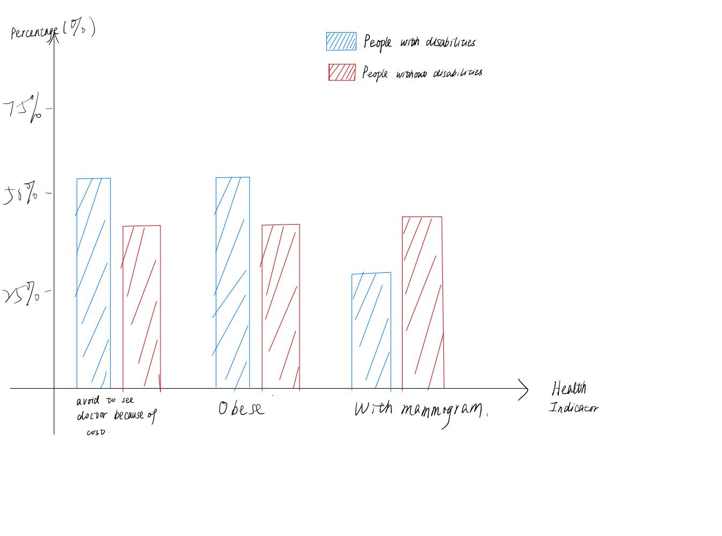

This is a bar plot comparing health indicators for patients with disabilities versus the general population. Health indicator will provide information about the health and healthcare status of individuals. For example, whether a person is obese, whether a person can access certain healthcare resource etc. This can highlight the health and health care inequalities faced by patients with disabilities.

(Data source: <https://www.ncbi.nlm.nih.gov/pmc/articles/PMC4355692/> )

**Sketch 2 –Interactive Map**

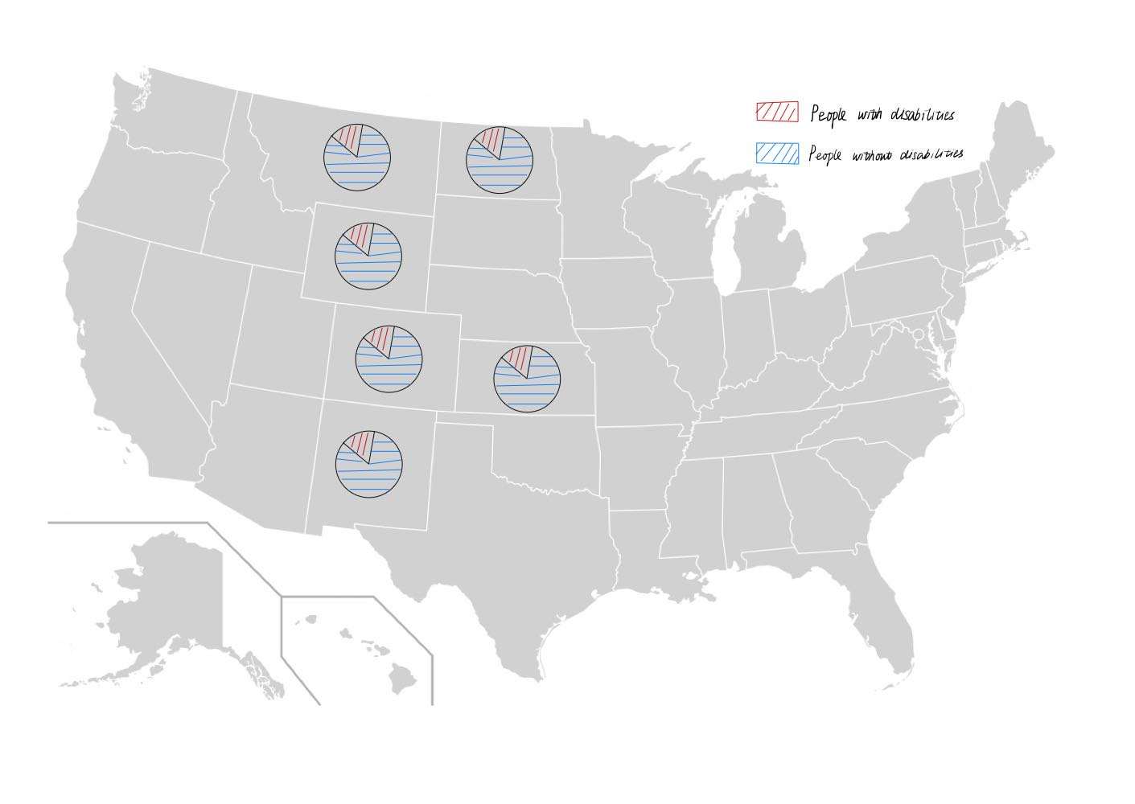

This is an interactive map of the United States showing the percentage of people with disabilities for each state. When the mouse is hovering over the corresponding state, it will show the exact number of percentage of disabled people in that state. This can highlight “one in four adults”, which means the people with disabilities is actually common in the United States.

(Data source: <https://www.statista.com/statistics/794278/disabled-population-us-by-state/> )

**Sketch 3 – Treemap**

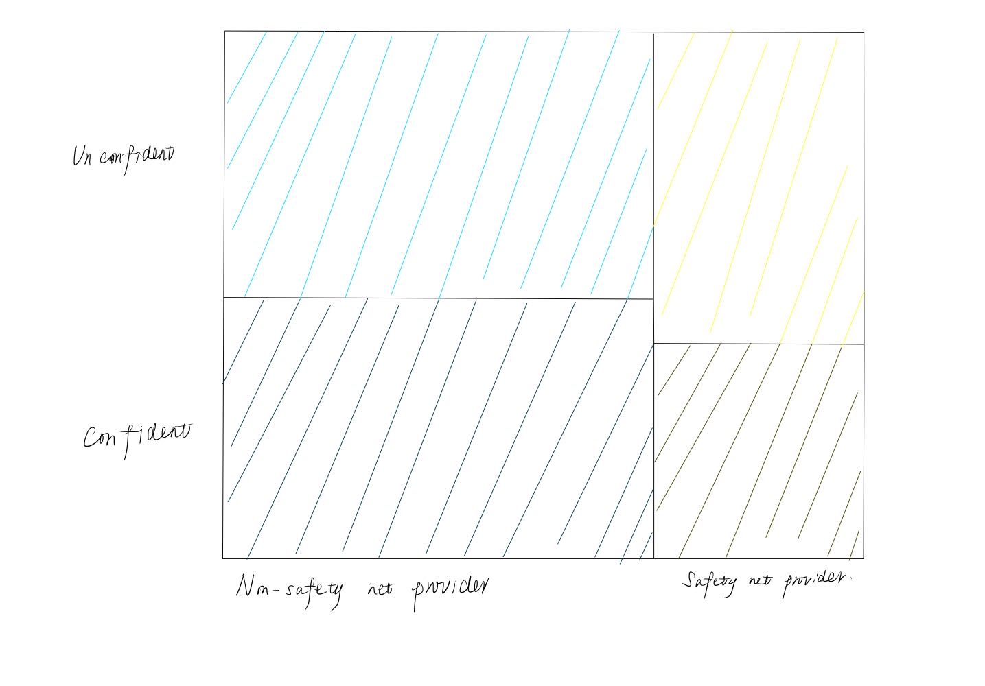

The tree map shows different types of physicians’ idea on whether they provide equal quality of care for people with disabilities. The figure is divided horizontally by the type of the physician, vertically by whether they are confident about providing equal quality of care for the disabled. The size of the area is decided by the number of people in that category. This can show the distribution of opinions among different groups of physicians to help readers understand more about how physicians think about the disabled.

(Data source: <https://www.ncbi.nlm.nih.gov/pmc/articles/PMC8722582/> )

**Sketch 4 – Timeline**

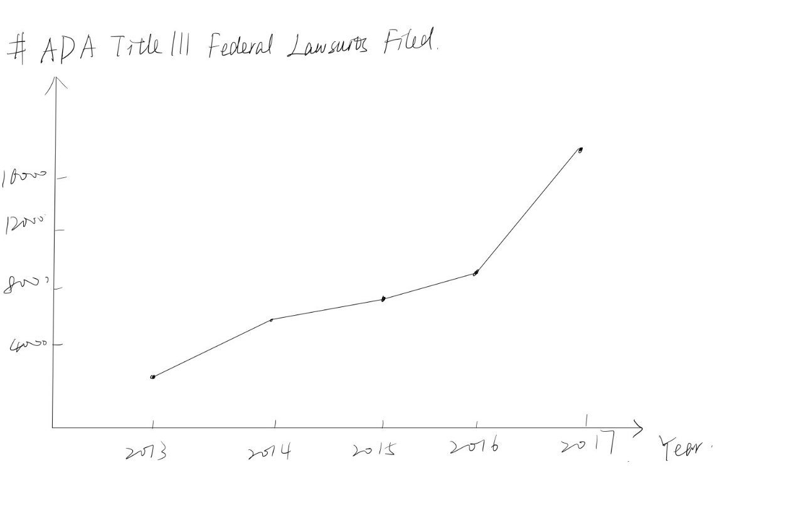

This is a timeline that shows the number of ADA Title III lawsuits each year. It can be used to demonstrate the sentence “Lawyers have filed more than 10,000 ADA Title III lawsuits each year since 2018” in the article. Also, it can show the total trend of legal and policy frameworks related to disability care.

(Data source: <https://www.adatitleiii.com/2022/02/ada-title-iii-federal-lawsuit-filings-hit-an-all-time-high/>)